DVB-SIS TS Reference Stream

Arrival time-stamping (ReadMineTask #221)

MAINDATA

**1 Synchronization** **3**

**2 Protocol Stack** **4**

**3 T2-MI packets** **5**

3.1 T2-MI packet definition 5

3.2 T2-MI payload definitions 6

3.2-1 DVB-T2 timestamp 6

3.2-2 Null timestamp 8

3.3 Timing of T2-MI packet transmission 8

3.3-1 Transport Stream syntax 10

3.4 Transport of T2-MI packets 11

3.5 Encapsulation of T2-MI packets in MPEG-2 TS 11

3.5-1 Description 11

**4 Transport Stream bitstream requirements** **14**

4.1 Transport Stream coding structure and parameters 14

4.1-1 System clock frequency 15

4.1-2 System clock frequency 16

4.1-3 Input to the Transport Stream system target decoder 17

**5 Program Clock Reference (PCR) timestamps** **20**

5.1 Introduction 20

5.1-1 Relation between ISCR and PCR 20

3.1-2 Insertion of PCRs 21

3.1-3 Synchronization between T2-Gateway and Modulator 21

2.1-4 Frequency of coding the program clock reference 22

2.1-5 System Clock Frequency 22

**6 Counting the Bits to determine the TS rate** **24**

**Annex B - T2 Modulator Information Packet (T2-MIP)** **25**

B.1 Use of the T2-MIP for over the air synchronization 25

B.2 T2-MIP Definition 27

B.2-1 field description 27

B.2-2 Transmission of the T2-MIP over DVB-T2 29

**Annex F - DVB-T2 Timestamp** **30**

F.1 Relationships 30

F.2 Rationale 30

# 1 Synchronization

Synchronization among multiple elementary streams is accomplished with Presentation Time Stamps (PTS) in the Program Stream and Transport streams. Time stamps are generally in units of 90 kHz, but the System Clock Reference (SCR), the Program Clock Reference (PCR) and the optional Elementary Stream Clock Reference (ESCR) have extensions with a resolution of 27 MHz. Decoding of N-elementary streams is synchronized by adjusting the decoding of streams to a common master time base rather than by adjusting the decoding of one stream to match that of another. The master time base may be one of the N-decoders’ clocks, the data source’s clock, or it may be some external clock.

Each program in a Transport Stream, which may contain multiple programs, may have its own time base. The time bases of different programs within a Transport Stream may be different.

Because PTSs apply to the decoding of individual elementary streams, they reside in the PES packet layer of both the Transport Streams and Program Streams. End-to-end synchronization occurs when encoders save time stamps at capture time, when the time stamps propagate with associated coded data to decoders, and when decoders use those time stamps to schedule presentations.

Synchronization of a decoding system with a channel is achieved through the use of the SCR in the Program Stream and by its analogue, the PCR, in the Transport Stream. The SCR and PCR are time stamps encoding the timing of the bit stream itself, and are derived from the same time base used for the audio and video PTS values from the same program. Since each program may have its own time base, there are separate PCR fields for each program in a Transport Stream containing multiple programs. In some cases it may be possible for programs to share PCR fields. Refer to 2.4.4, Program Specific Information (PSI), for the method of identifying which PCR is associated with a program. A program shall have one and only one PCR time base associated with it.

# 2 Protocol Stack

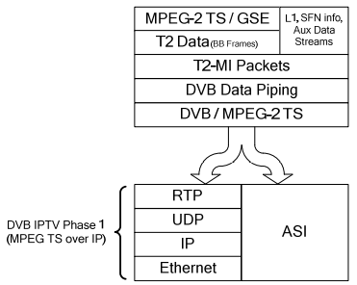

Figure 2a: T2-MI Protocol Stack

The DVB-T2 Modulator Interface (T2-MI) carries the DVB-T2 system inputs, MPEG-2 TS and/or Generic Streams, encapsulated within DVB-T2 Baseband Frames [1].

In addition the T2-MI also carries other T2 data including, but not limited to:

* L1 signaling data to enable the construction of T2 frames by the modulator;
* IQ vector data for any auxiliary streams;
* **DVB-T2 timestamp (for synchronization)**; and
* Future Extension Frame (FEF) data. With the exception of the DVB-T2 timestamp, all this information is transmitted as part of the on-air DVB-T2 signal.

The synchronization timestamp data is not transmitted over-air but used by a modulator to define the precise time of emission of the DVB-T2 signal. A special case exists where relay stations forming part of a SFN are fed over air from a master station on a different frequency, since they also require access to the synchronization data (see annex B).

The T2 data is packetized into T2-MI packets and encapsulated into DVB/MPEG Transport Stream packets using Data Piping, in accordance with ETSI EN 301 192 [4], clause 4.

# 3 T2-MI packets

Several different types of T2-related data may be sent over the T2-MI through the use of T2-MI packets. All fields are uimsbf unless otherwise stated.

## 3.1 T2-MI packet definition

The T2-MI packet format is shown in figure 3.1a.

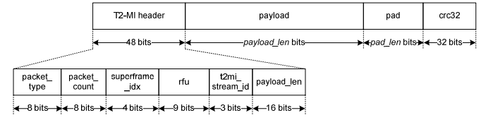

Figure 3.1a: T2-MI packet format

Each T2-MI packet is composed of a 6 byte header, followed by a variable-length payload part plus padding, when required, and a 32-bit CRC tail for error detection.

The T2-MI packet consists of the following fields:

**packet_type (8 bits)** indicates the type of the payload carried by the T2-MI packet. The currently defined values are shown in table 1 and their associated formats defined in the following clauses. All other values are Reserved for Future Use (RFU).

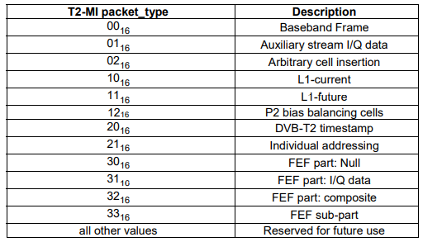

Table 3.1b: T2-MI packet types

## 3.2 T2-MI payload definitions

### 3.2-1 DVB-T2 timestamp

T2-MI packets with a packet_type of 2016 shall carry the DVB-T2 timestamp, used to synchronize the output of DVB-T2 modulators. Two mechanisms are defined; absolute and relative.

The T2-MI packet payload for this data is shown in figure 3.2-1a.

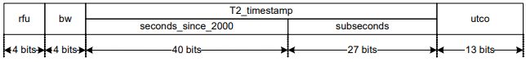

Figure 3.2-1a: DVB-T2 timestamp payload

**rfu (4 bits)** bits reserved for future use and shall all be set to 02.

**bw (4 bits)** indicates the system bandwidth, in accordance with clause 9.5 of ETSI EN 302 755 [1]. This also defines the units of the subsecond field of the T2 timestamp as shown in table 3.2-1b.

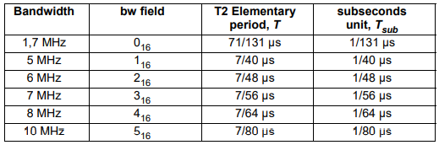

Table 3.2-1b: Bandwidths and subsecond field units for the T2 timestamp

**seconds_since_2000 (40 bits)** is a count of the number of seconds since 2000-01-01 T 00:00:00 UTC as an unsigned 40- bit quantity and is used to define an absolute time of emission. This count shall increase for every SI second that elapses. A value of 000000000016 indicates a relative timestamp, defined only by the subseconds field below.

**subseconds (27 bits)** defines the number of subsecond units since the time expressed in the seconds field. The value is expressed as an unsigned integer.

**T2_timestamp:** Taken together, the seconds_since_2000 and subseconds fields define the DVB-T2 timestamp and the time of emission of a DVB-T2 transmission. Annex F details the relationship between the DVB-T2 timestamp and other time standards.

When the **seconds_since_2000** field is non-zero, the emission time shall be given by **seconds_since_2000 + subseconds** × Tsub.

When the **seconds_since_2000** field is all zeros, the emission time shall be **subseconds** × Tsub after the SI second boundary preceding it.

NOTE 1: The SI second boundary can be given by the relevant edge of a 1 pulse per second signal.

The emission time shall be the time at which 50 % of the energy of the first time sample from the IFFT of the "C" part of the P1 preamble symbol of the first T2 transmission frame of the relevant super-frame shall have been radiated on air. All T2 frames within a super-frame shall have the same timestamp value. The timestamps of subsequent super-frames shall be increased by the duration of the super-frame.

NOTE 2: Based on the knowledge of the DVB-T2 Timestamp of a particular super-frame, and the L1 signaling pertaining to a particular T2 frame, a modulator should be able to determine the required emission time for any such T2 frame even if it misses the beginning of a super-frame, e.g. after a restart. To do this, the modulator will then need to take into account the frame index and the frame length of the T2 frame as well as the total lengths of any FEF parts having occurred in the super-frame before the current T2 frame.

**utco (13 bits)** is the offset (in seconds) between UTC and the seconds_since_2000 field. The value is expressed as an unsigned integer. As of February 2009, the value shall be 2 and shall change as a result of each new leap second prescribed by the International Earth Rotation and Reference Systems Service (IERS).

NOTE 3: The value contained in this field has no effect on the time of emission from the modulator but it may be useful to a modulator implementation where only a source of UTC time is available.

NOTE 4: The maximum latency of the distribution system, plus the maximum processing delay of modulator implementations (i.e. the relevant Tmin values from clause 5.5) for the mode being broadcast will need to be known. Where the range of total delays exceeds 1 second the use of the Absolute T2 Timestamp will be necessary to avoid ambiguous super-frame start times.

### 3.2-2 Null timestamp

When it is not required to synchronize the output of multiple DVB-T2 modulators, the DVB-T2 timestamp shall be signaled as null by setting all bits of the **T2_timestamp** and **utco** fields to 12. When generating a composite signal, even in an MFN, Null timestamps shall not be used, to ensure the correct relative timing of the different T2-MI streams. A DVB-T2 timestamp packet shall always be sent (whether carrying a Null timestamp or otherwise) to indicate the bandwidth of the T2 transmission to the T2 modulator.

## 3.3 Timing of T2-MI packet transmission

In this clause, Tmin1, Tmin2, Tmin3, Tmax1, Tmax2 , Tmax3 and Tmax4 represent specification values for a modulator and should be quoted by modulator manufacturers. Network operators should design the timing of a network carrying T2-MI taking into account the values for each of the modulators in the network.

The T2-MI packets of type 0016, 0116, 0216, 1016, 1216 and 2016 with a given **frame_idx** shall be sent so as to arrive at the modulator no later than Tmin1 before the beginning of the corresponding T2-frame is due for transmission.

The T2-MI packet of type 1116, if used, with a given **frame_idx**, shall be sent so as to arrive at the modulator no later than Tmin2 before the beginning of the corresponding T2-frame is due for transmission.

T2-MI packets of type 3016, 3116, 3216 and 3316 with a given fef_idx shall arrive no later than Tmin3 before the corresponding FEF part is due for transmission. T2-MI packets of type 0016 with a given frame_idx shall arrive no earlier than TIF+Tmax1 before the beginning of the corresponding T2-frame is due for transmission, where:

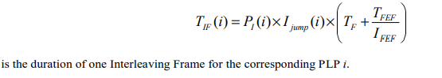

For the purposes of this clause, the time of arrival of a T2-MI packet at the modulator shall be defined as the time at which the packet is delivered by the underlying DVB data piping protocol (see clause 6.1). The timing and transmission order of T2-MI packets is summarized in figure 33a.

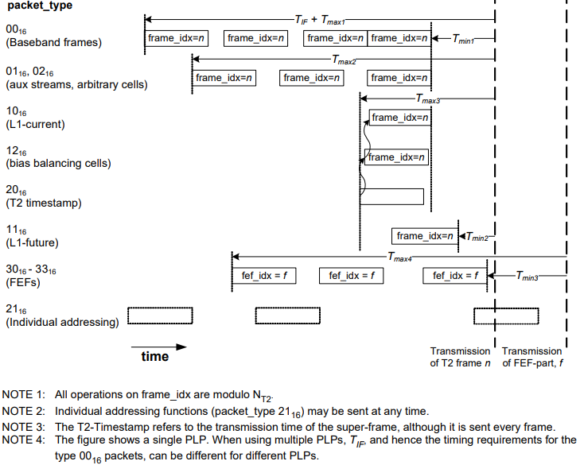

Figure 33a: Timing and transmission order of T2-MI packets

Where a modulator is generating multiple T2 profiles (e.g. a combination of T2-Base and T2-Lite profiles), the T2 data for each profile is carried in a self-consistent T2-MI stream for each profile.

### 3.3-1 Transport Stream syntax

This annex is an informative annex presenting graphically the Transport Stream and Program Stream syntax. This annex in no way replaces any normative clause(s).

In order to produce clear drawings, not all fields have been fully described or represented. Reserved fields may be omitted or indicated by areas with no detail. Field lengths are indicated in bits.

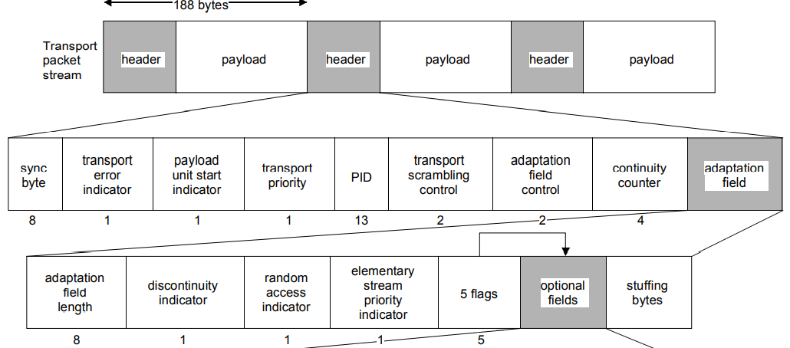

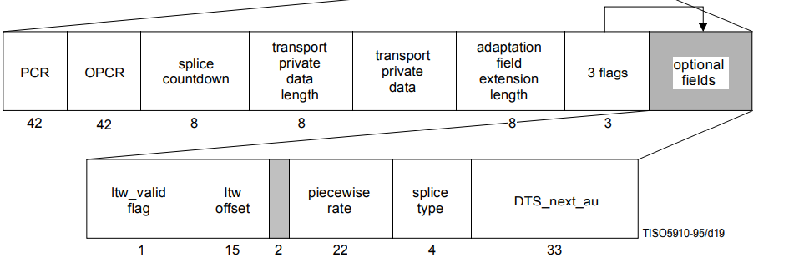

Figure 3.3-1a: Transport Stream syntax diagram

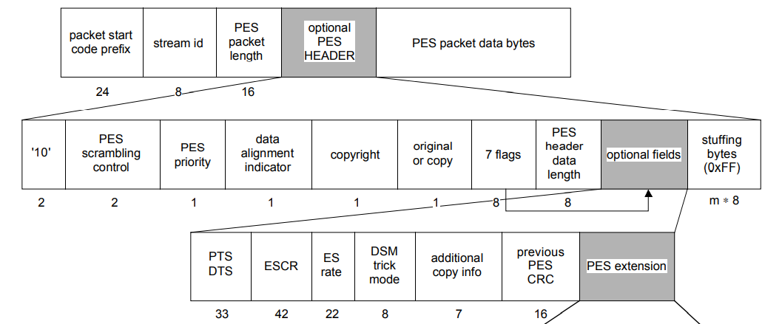

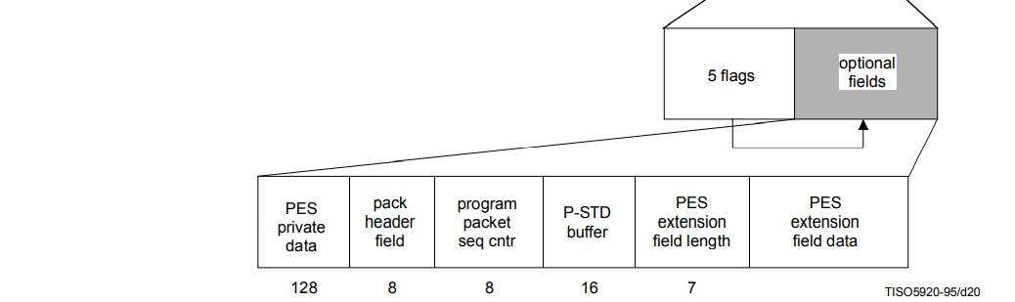

Figure 3.3-b: PES packet syntax diagram

## 3.4 Transport of T2-MI packets

The structure of the T2-MI protocol stack described in clause 4.3 allows two mechanisms for distribution; one for traditional ASI interfaces, the other for IP based networks.

Both mechanisms rely on first inserting the T2-MI packets into DVB/MPEG-2 TS packets which can then be interfaced to a distribution network via such interfaces as described in CENELEC EN 50083-9 [i.2].

The resulting TS can then be further encapsulated into an IP stream using the DVB IPTV standard, ETSI TS 102 034 [5].

## 3.5 Encapsulation of T2-MI packets in MPEG-2 TS

The insertion of T2-MI packets into MPEG-2 TS packets shall be in accordance with ETSI EN 301 192 [4], clause 4, "Data Piping". This mechanism allows for the insertion of data directly into the payload of MPEG-2 TS packets with the minimum of additional overhead.

### 3.5-1 Description

The T2-MI packets are inserted, one after another, into the payload of MPEG-2 TS packets. Each new T2-MI packet shall start immediately following the previous one. A TS packet may contain more than one T2-MI packet. T2-MI packets that are too big to fit into the payload of a single TS packet shall be split across multiple TS packets as required.

Since the length of each T2-MI packet is variable (indicated by the **payload_len** field in the T2-MI packet header), the start of a TS packet's payload does not necessarily coincide with the start of a T2-MI packet. To enable synchronization within a device receiving T2-MI, the "payload_unit_start_indicator" bit in the TS header shall be used to indicate that a new T2-MI packet starts somewhere within the current TS packet. When this is the case an 8-bit pointer shall be positioned as the first payload byte of the TS packet, indicating the offset from the start of the TS payload to the first byte of the first T2-MI packet. This 8-bit pointer field (uimsbf) shall indicate the number of bytes immediately following the pointer field until the first byte of the first T2-MI packet that is present in the payload of the Transport Stream packet (i.e. a value of 0016 in the pointer field indicates that the T2-MI packet starts immediately after the pointer field). This is illustrated in figure 3.5-1a.

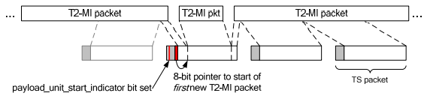

Figure 3.5-1a: Encapsulation of T2-MI Packets in MPEG-2 TS

Using this mechanism the T2-MI packet can begin anywhere in the TS packet. There is no requirement to have T2-MI packets beginning at the start of a TS packet and no need for unnecessary stuffing.

NOTE 1: Since the TS packets containing T2-MI packets are carrying a data type not defined by MPEG, ETSI EN 301 192 [4] allows the use of the "payload_unit_start_indicator" bit in this "service private way".

When a T2-MI packet ends at the last-but-one byte of a TS packet and starts in a previous TS packet, the one remaining byte does not allow space for both the insertion of the 8-bit pointer field and the first byte of the next T2-MI packet. In this case the size of the payload of the TS packet shall be reduced by one byte through the use of adaptation field stuffing [7] such that the current T2-MI packet finishes at the end of the TS packet payload. The next T2-MI packet shall start in the next TS packet having the same PID.

NOTE 2: Arbitrary amounts of padding may also be added, if required, at this layer through the use of arbitrary numbers of stuffing bytes in the adaptation field of the transport stream packet [7].

EXAMPLE: A T2-MI packet is being transmitted. Most of the T2-MI packet has been transmitted and only 50 bytes remain to be sent. The next T2-MI packet is not yet available and there are therefore not enough bytes to fill up a TS packet. To allow this TS packet to be transmitted immediately, an adaptation field of total length 134 bytes (adaptation_field_length = 133) containing stuffing bytes can be inserted before the payload.

For carriage over managed distribution networks a minimum of PSI should be used in order to prevent erroneous alarms from being set. This would normally comprise a PAT, and PMT for a single "Program" as defined in ISO/IEC 13818-1 [7]. The Stream Type to be used in the PMT is not defined in ETSI EN 301 192 [4]. For the purposes of interoperability, it should be set to 0616 and, if used, the T2MI_descriptor [8] shall be added to a PMT sub-table, for every T2-MI stream. Similarly, some networks may require the carriage of mandatory DVB SI tables, and reference should be made to ETSI EN 300 468 [8] for the appropriate values to be used in such tables. When NUM_RF=1, the maximum rate of the transport stream carrying the T2-MI shall be 72 Mbps.

# 4 Transport Stream bitstream requirements

## 4.1 Transport Stream coding structure and parameters

The ITU-T Rec. H.222.0 | ISO/IEC 13818-1 Transport Stream coding layer allows one or more programs to be combined into a single stream. Data from each elementary stream are multiplexed together with information that allows synchronized presentation of the elementary streams within a program.

A Transport Stream consists of one or more programs. Audio and video elementary streams consist of access units.

Elementary Stream data is carried in PES packets. A PES packet consists of a PES packet header followed by packet data. PES packets are inserted into Transport Stream packets. The first byte of each PES packet header is located at the first available payload location of a Transport Stream packet.

The PES packet header begins with a 32-bit start-code that also identifies the stream or stream type to which the packet data belongs. The PES packet header may contain decoding and presentation time stamps (DTS and PTS). The PES packet header also contains other optional fields. The PES packet data field contains a variable number of contiguous bytes from one elementary stream.

Transport Stream packets begin with a 4-byte prefix, which contains a 13-bit Packet ID (PID), defined in Table 2-2. The PID identifies, via the Program Specific Information (PSI) tables, the contents of the data contained in the Transport Stream packet. Transport Stream packets of one PID value carry data of one and only one elementary stream.

The PSI tables are carried in the Transport Stream. There are four PSI tables:

* Program Association Table;
* Program Map Table;
* Conditional Access Table;
* Network Information Table.

These tables contain the necessary and sufficient information to demultiplex and present programs. The Program Map Table, in Table 2-28, specifies, among other information, which PIDs, and therefore which elementary streams are associated to form each program. This table also indicates the PID of the Transport Stream packets which carry the PCR for each program. The Conditional Access Table shall be present if scrambling is employed. The Network Information Table is optional and its contents are not specified by this Recommendation | International Standard.

Transport Stream packets may be null packets. Null packets are intended for padding of Transport Streams. They may be inserted or deleted by re-multiplexing processes and, therefore, the delivery of the payload of null packets to the decoder cannot be assumed.

This Recommendation | International Standard does not specify the coded data which may be used as part of conditional access systems. This Specification does, however, provide mechanisms for program service providers to transport and identify this data for decoder processing, and to reference correctly data which are specified by this Specification. This type of support is provided both through Transport Stream packet structures and in the conditional access table (refer to Table 2-27 of the PSI).

### 4.1-1 System clock frequency

Timing information referenced in the T-STD is carried by several data fields defined in this Specification. Refer to 2.4.3.4 and 2.4.3.6. In PCR fields this information is coded as the sampled value of a program’s system clock. The PCR fields are carried in the adaptation field of the Transport Stream packets with a PID value equal to the PCR_PID defined in the TS_program_map_section of the program being decoded.

Practical decoders may reconstruct this clock from these values and their respective arrival times. The following are minimum constraints which apply to the program’s system clock frequency as represented by the values of the PCR fields when they are received by a decoder.

The value of the system clock frequency is measured in Hz and shall meet the following constraints:

27 000 000 − 810 ≤ system_clock_frequency ≤ 27 000 000 + 810

rate of change of system_clock_frequency with time ≤ 75 × 10−3 Hz/s

NOTE – Sources of coded data should follow a tighter tolerance in order to facilitate compliant operation of consumer recorders and playback equipment.

A program’s system_clock_frequency may be more accurate than required. Such improved accuracy may be transmitted to the decoder via the System clock descriptor described in 2.6.20.

Bit rates defined in this Specification are measured in terms of system_clock_frequency. For example, a bit rate of 27 000 000 bits per second in the T-STD would indicate that one byte of data is transferred every eight (8) cycles of the system clock.

The notation "system_clock_frequency" is used in several places in this Specification to refer to the frequency of a clock meeting these requirements. For notational convenience, equations in which PCR, PTS, or DTS appear, lead to values of time which are accurate to some integral multiple of (300 × 233/system_clock_frequency) seconds. This is due to the encoding of PCR timing information as 33 bits of 1/300 of the system clock frequency plus 9 bits for the remainder, and encoding as 33 bits of the system clock frequency divided by 300 for PTS and DTS.

### 4.1-2 System clock frequency

Timing information referenced in the T-STD is carried by several data fields defined in this Specification. Refer to 2.4.3.4 and 2.4.3.6. In PCR fields this information is coded as the sampled value of a program’s system clock. The PCR fields are carried in the adaptation field of the Transport Stream packets with a PID value equal to the PCR_PID defined in the TS_program_map_section of the program being decoded.

Practical decoders may reconstruct this clock from these values and their respective arrival times. The following are minimum constraints which apply to the program’s system clock frequency as represented by the values of the PCR fields when they are received by a decoder.

The value of the system clock frequency is measured in Hz and shall meet the following constraints:

27 000 000 − 810 ≤ system_clock_frequency ≤ 27 000 000 + 810

rate of change of system_clock_frequency with time ≤ 75 × 10−3 Hz/s

NOTE – Sources of coded data should follow a tighter tolerance in order to facilitate compliant operation of consumer recorders and playback equipment.

A program’s system_clock_frequency may be more accurate than required. Such improved accuracy may be transmitted to the decoder via the System clock descriptor described in 2.6.20.

Bit rates defined in this Specification are measured in terms of system_clock_frequency. For example, a bit rate of 27 000 000 bits per second in the T-STD would indicate that one byte of data is transferred every eight (8) cycles of the system clock.

The notation "system_clock_frequency" is used in several places in this Specification to refer to the frequency of a clock meeting these requirements. For notational convenience, equations in which PCR, PTS, or DTS appear, lead to values of time which are accurate to some integral multiple of (300 × 233/system_clock_frequency) seconds. This is due to the encoding of PCR timing information as 33 bits of 1/300 of the system clock frequency plus 9 bits for the remainder, and encoding as 33 bits of the system clock frequency divided by 300 for PTS and DTS.

### 4.1-3 Input to the Transport Stream system target decoder

Input to the Transport Stream System Target Decoder (T-STD) is a Transport Stream. A Transport Stream may contain multiple programs with independent time bases. However, the T-STD decodes only one program at a time. In the T-STD model all timing indications refer to the time base of that program.

Data from the Transport Stream enters the T-STD at a piecewise constant rate. The time t(i) at which the i-th byte enters the T-STD is defined by decoding the program clock reference (PCR) fields in the input stream, encoded in the Transport Stream packet adaptation field of the program to be decoded and by counting the bytes in the complete Transport Stream between successive PCRs of that program. The PCR field (see equation 2-1) is encoded in two parts: one, in units of the period of 1/300 times the system clock frequency, called program_clock_reference_base (see equation 2-2), and one in units of the system clock frequency called program_clock_reference_extension (see equation 2-3). The values encoded in these are computed by PCR_base(i) (see equation 2-2) and PCR_ext(i) (see equation 2-3) respectively. The value encoded in the PCR field indicates the time t(i), where i is the index of the byte containing the last bit of the program_clock_reference_base field.

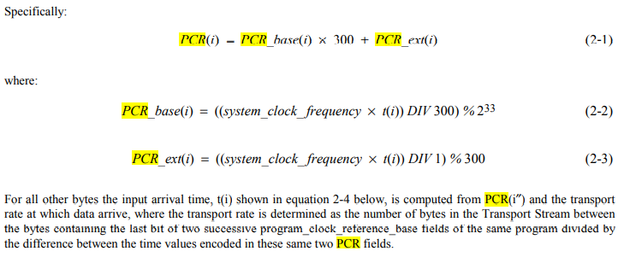

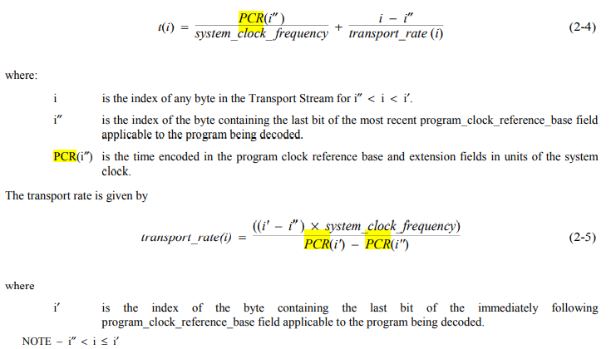

In the case of a timebase discontinuity, indicated by the discontinuity_indicator in the transport packet adaptation field, the definition given in equation 2-4 and equation 2-5 for the time of arrival of bytes at the input to the T-STD is not applicable between the last PCR of the old timebase and the first PCR of the new timebase. In this case the time of arrival of these bytes is determined according to equation 2-4 with the modification that the transport rate used is that applicable between the last and next to last PCR of the old timebase.

A tolerance is specified for the PCR values. The PCR tolerance is defined as the maximum inaccuracy allowed in received PCRs. This inaccuracy may be due to imprecision in the PCR values or to PCR modification during re-multiplexing. It does not include errors in packet arrival time due to network jitter or other causes. The PCR tolerance is ± 500 ns.

In the T-STD model, the inaccuracy will be reflected as an inaccuracy in the calculated transport rate using equation 2-5.

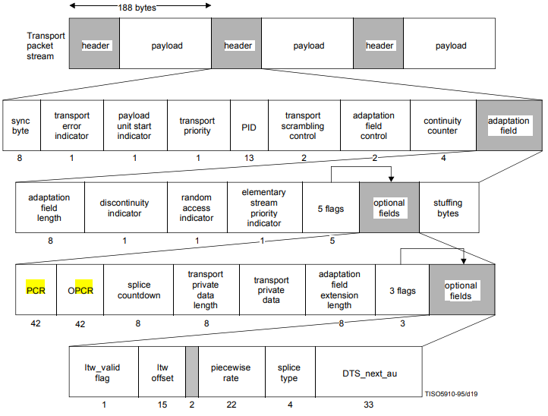

Figure 1a: Transport Stream syntax diagram

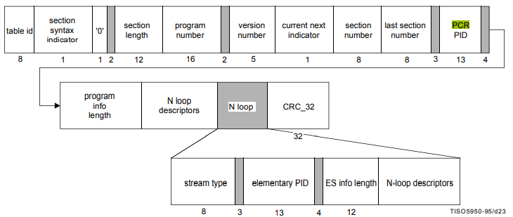

Figure 1b: TS program map section diagram

PCR_PID – This is a 13-bit field indicating the PID of the Transport Stream packets which shall contain the PCR fields valid for the program specified by program_number. If no PCR is associated with a program definition for private streams, then this field shall take the value of 0x1FFF. Refer to the semantic definition of PCR in 2.4.3.5 and Table 2-3 for restrictions on the choice of PCR_PID value.

# 5 Program Clock Reference (PCR) timestamps

## 5.1 Introduction

This method uses the ISCR [1] as a shared reference clock and uses Program Clock Reference (PCR) [7] timestamps to convey the ISCR from T2-MI transmitter to T2-MI receiver. In general, this method is similar to and compatible with the synchronization of decoders with encoders in MPEG-2 Transport Streams, using PCR timestamps. This is defined in ISO/IEC 13818-1 [7].

### 5.1-1 Relation between ISCR and PCR

To keep the method compatible with MPEG-2 Systems, the PCRs in this method are based on a 27-MHz clock. Conversion between ISCR and PCR clock values is possible since the ratio between PCR and ISCR-clock frequency is exact and can be expressed as an ratio with an integer numerator and denominator as shown in table 5.1-1a.



Table 5.1-1a: Bandwidths and ratio between PCR and ISCR-clock frequency

A block diagram of a T2-gateway that is able to insert PCRs into the output T2-MI is shown in Figure 5.1-1b.

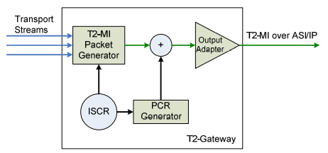

Figure 5.1-1b: PCR insertion in the T2-gateway

The T2-gateway is responsible for inserting the PCRs at such places that the timing of the T2-MI packet transmission can be reconstructed through the methods described below. The output T2-MI can then be recorded to a file.

NOTE: If the ISCRs and PCRs are generated from a common clock, this is signaled in the T2MI_descriptor [8] carried in the PMT, when present.

### 5.1-2 Insertion of PCRs

The PCR values are inserted into the Transport Stream carrying the T2-MI packets. The suggested method is to insert the PCRs on the PID that carries the T2-MI packets. Where multiple T2 profiles (T2-MI streams) are being used, a PCR may be inserted for each profile on the unique profile PID. This applies both to the case where a single TS is used for both profiles and for the case when different TSs are used. Alternatively a different PCR-only PID could be used if required in both the single profile and multiple profile cases.

If the Transport Stream comprises a PAT and PMT, the PCR PID should be defined in the PMT [7].

### 5.1-3 Synchronization between T2-Gateway and Modulator

The ratio between the PCR- and ISCR clocks is known exactly. If the delay between T2-gateway and modulator is constant, the modulator can extract the PCR values and use them to synchronize its ISCR clock directly. In practice the network will introduce some variable delay (jitter) and therefore some form of control loop will be required.

A block diagram of a modulator that is able to synchronize its ISCR-clock based on the PCR values in the T2-MI is shown in Figure 3.1-3a.

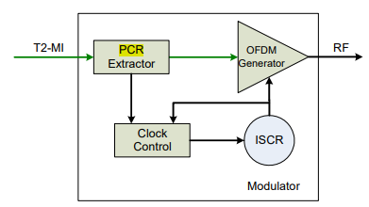

Figure 5.1-3a: ISCR synchronization in the modulator based on PCR values

### 5.1-4 Frequency of coding the program clock reference

The Transport Stream shall be constructed such that the time interval between the bytes containing the last bit of program_clock_reference_base fields in successive occurrences of the PCRs in Transport Stream packets of the PCR_PID for each program shall be less than or equal to 0,1 s. Thus:

| | t(i) − t(i′) ≤ 0.1 s

for all i and i′ where i and i′ are the indexes of the bytes containing the last bit of consecutive program_clock_reference_base fields in the Transport Stream packets of the PCR_PID for each program.

There shall be at least two (2) PCRs, from the specified PCR_PID within a Transport Stream, between consecutive PCR discontinuities (refer to 2.4.3.4) to facilitate phase locking and extrapolation of byte delivery times.

### 5.1-5 System Clock Frequency

Timing information referenced in the T-STD is carried by several data fields defined in this Specification. Refer to 2.4.3.4 and 2.4.3.6. In PCR fields this information is coded as the sampled value of a program’s system clock. The PCR fields are carried in the adaptation field of the Transport Stream packets with a PID value equal to the PCR_PID defined in the TS_program_map_section of the program being decoded.

Practical decoders may reconstruct this clock from these values and their respective arrival times. The following are minimum constraints which apply to the program’s system clock frequency as represented by the values of the PCR fields when they are received by a decoder.

The value of the system clock frequency is measured in Hz and shall meet the following constraints:

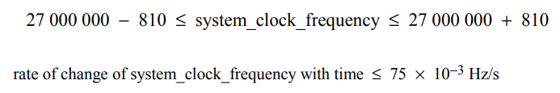

A program’s system_clock_frequency may be more accurate than required. Such improved accuracy may be transmitted to the decoder via the System clock descriptor described in 2.6.20.

Bit rates defined in this Specification are measured in terms of system_clock_frequency. For example, a bit rate of 27 000 000 bits per second in the T-STD would indicate that one byte of data is transferred every eight (8) cycles of the system clock.

The notation "system_clock_frequency" is used in several places in this Specification to refer to the frequency of a clock meeting these requirements. For notational convenience, equations in which PCR, PTS, or DTS appear, lead to values of time which are accurate to some integral multiple of (300 × 233/system_clock_frequency) seconds. This is due to the encoding of PCR timing information as 33 bits of 1/300 of the system clock frequency plus 9 bits for the remainder and encoding as 33 bits of the system clock frequency divided by 300 for PTS and DTS.

# 6 Counting the Bits to determine the TS rate

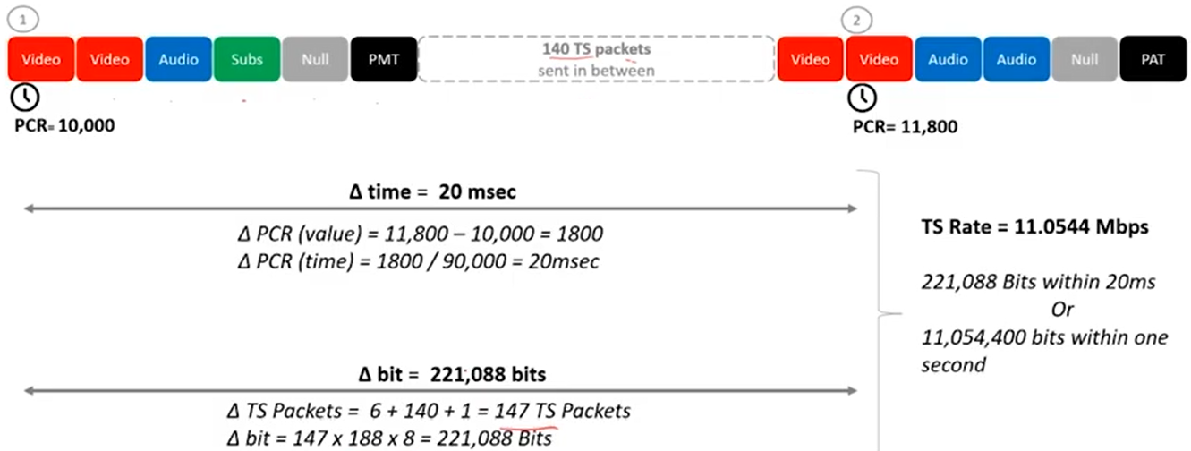

Figure 8a: Counting the Bits to determine the TS rate

# Annex B - T2 Modulator Information Packet (T2-MIP)

## B.1 Use of the T2-MIP for over the air synchronization

The T2-MI packets, as described in the main body of the present document, are only used by the modulator and not broadcast from the transmitter. For use cases where several repeaters are receiving a DVB-T2 signal from a main transmitter and retransmitting it on a common second frequency, in an SFN, there is a need to make this retransmission from the repeaters in a time-synchronized way. This situation is detailed in Figure B.1a.

There are two types of repeater. They may be:

* regenerative repeaters, i.e. demodulating the DVB-T2 signal and the re-modulating the demodulated transport streams to form a regenerated DVB-T2 signal which is then retransmitted; or
* transposers, i.e. they would shift frequency, amplify, delay and transmit the received DVB-T2 signal without a full re-modulation process taking place.

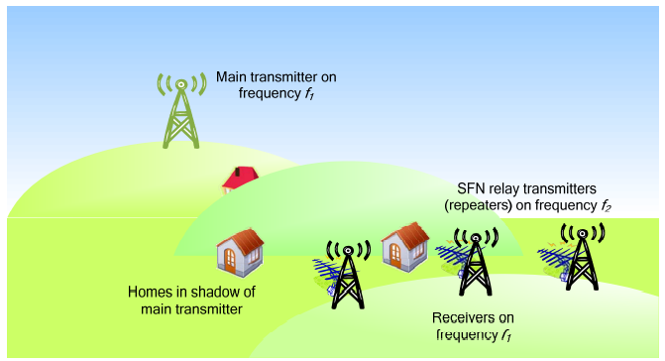

Figure B.1a: SFN Relays taking input over the air from the Main transmitter

In this situation, the relay transmitters do not have access to the T2-MI packets that were used by the modulator at the main transmitter to generate the on-air, physical layer, T2 signal.

Because the physical layer signal has been defined at the main transmitter, the only synchronization data required by the relay is the time of emission. This is carried by a special Transport Stream packet (the T2-MIP) which is carried in the over-air DVB-T2 signal.

This TS packet can be decoded by a demodulator in each repeater to extract the required emission time of a particular super-frame of the DVB-T2 signal. Based on this information, and on the knowledge of the timing of the currently-received super-frame, each repeater can apply the appropriate time delay to ensure emission of the superframe at the required time.

This version of the T2-MI specification only defines the T2-MIP to be carried over transport streams, which is derived from the equivalent packet used in DVB-T networks [3]. There is currently no equivalent specification for such a mechanism to synchronize networks carrying services over other transports, such as GSE [2].

See Figure B.2b for the architecture of such a network.

NOTE: The T2-MIP inserter resides in the T2 Gateway, as it is this unit that defines the construction of the T2 Frame and Super-frame, and hence the timing relationship of TS packets to the physical layer modulation.

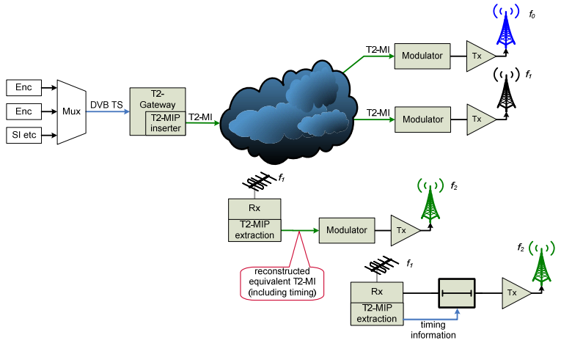

Figure B.2b: Generic architecture of over-air distribution of the T2-MIP to a SFN Sub-network

Under this condition, it is envisaged that the receiver at the relay station would deconstruct the incoming DVB-T2 signal into the constituent parts such that it could effectively pass an equivalent of the T2-MI signal on to the relay's modulator. This is necessary to ensure that every relay's modulator constructs the air interface identically at each station in the SFN.

Where the network is broadcasting multiple T2 Profiles (e.g. a combination of T2-Base and T2-Lite profiles), accurate reconstruction of the physical layer signal will need to be maintained for all profiles.

## B.2 T2-MIP Definition

### B.2-1 field description

The T2-MIP is an MPEG-2 compliant Transport Stream (TS) packet [7], made up of a 4 byte header and 184 data bytes. The organization of the T2-MIP is shown in Table B.2-1a.

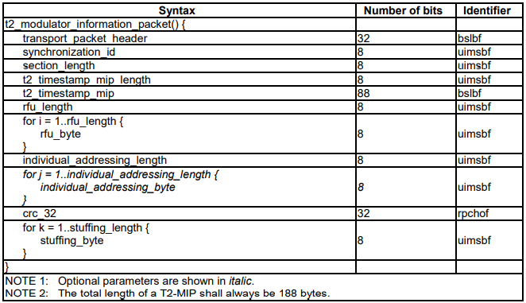

Table B.2-1a: DVB-T2 Modulator Information PAcket (T2-MIP)

**transport_packet_header (32 bits)** shall comply with ISO/IEC 13818-1 [7], clause 2.4.3.2.

* The PID value for the T2-Modulator Information Packet (T2-MIP) shall be 1516.
* The payload_unit_start_indicator is not used by the SFN synchronization function and shall be set to 1.
* The transport_priority value is not used by the SFN synchronization function and shall be set to 1.
* The transport_scrambling_control value shall be set to 00 (not scrambled).
* The adaptation_field_control value shall be set to 01 (payload only).
* All other parameters are according to ISO/IEC 13818-1 [7], clause 2.4.3.2.
* The Transport Packet Header (TPH) is mandatory.

**Mandatory T2-MIP fields**

**synchronization_id (8 bits)** is used to identify the synchronization scheme used. For DVB-T2 the value shall be 0216.

NOTE 1: The values of synchronization_id that apply for different transmissions systems are defined in table 2 of ETSI TS 101 191 [3].

**section_length (8 bits)** specifies the number of bytes following immediately after the section_length field until, and including, the last byte of the crc_32 but not including any stuffing_byte. The section_length shall not exceed 182 bytes.

**t2_timestamp_mip_length (8 bits)** specifies the length in bytes of the t2_timestamp_mip field that follows. The value is currently fixed at 1110.

**t2_timestamp_mip (88 bits)** is in the identical format to that specified for the complete payload of the T2-MI packet with packet type 2016 (see clause 5.2.7). The values expressed by this field refer to the emission time from the repeater of the T2 super-frame in which the last bit of the payload of the TS packet carrying the T2-MIP appears.

NOTE 2: The value of the T2 timestamp carried by the T2-MIP may be different from that contained in packet type 2016 of the T2-MI interface being used as input to the modulator of the main station.

**rfu_length (8 bits)** specifies the number of **rfu_bytes** that follow. A value of 0016 indicates that there are no following **rfu_bytes**. This value is currently fixed at 0010, i.e. there are no **rfu_bytes** defined.

**rfu_byte** is one byte of a variable number of bytes that are reserved for future use, the number of which is defined by the **rfu_length** field. All bytes shall have the value 0016.

**individual_addressing_length (8 bits)** gives the total length of the individual addressing loop in bytes. If individual addressing of transmitters is not performed the field value is 0016 and there shall be no **individual_addressing_byte** field.

**individual_addressing_byte** contains the bytes of the **individual_addressing_data** field of a T2-MI packet of type 2116 (see clause 5.2.8).

**crc_32 (32 bits)** is calculated across all other bits in the packet, including the **transport_packet_header** but excluding the **stuffing_byte** field, in accordance with annex A.

**stuffing_byte** shall have the value FF16. There shall be a multiple of **stuffing_bytes** such that the **t2_modulator_information_packet** is exactly 188 bytes long.

NOTE 3: Whilst the values for the **t2_timestamp** field and the **individual_addressing_bytes** follow the format of the payloads of T2-MI packet types 2016 and 2116 respectively, the values carried may be different to those carried in these packets within the T2-MI.

### B.2-2 Transmission of the T2-MIP over DVB-T2

The T2-MIP may be transmitted in one or more of the transport streams being sent over DVB-T2. If the T2-MIP is used there has to be at least one complete T2-MIP within a T2 super-frame for each T2 profile. The T2-MIP may be sent at any time within the super-frame and the timing may be different from super-frame to super-frame (see the definition of the **t2_timestamp_mip** field in clause B.2.1).

Where multiple PLPs are used, only one of the PLPs should carry a T2-MIP. If it is carried in multiple PLPs then the T2 timestamp shall be identical within all PLPs for that super-frame.

NOTE: Where a common PLP is available, this is the preferred location for the T2-MIP.

# Annex F - DVB-T2 Timestamp

## F.1 Relationships

The relationships between UTC, TAI, GPS Time and the DVB-T2 Timestamp (as defined in clause 5.2.2) are, as at the time of writing (February 2009), as follows:

* GPS = TAI - 19 s (constant).
* UTC = TAI - 34 s (variable due to leap seconds).
* UTC = GPS - 15 s (variable due to leap seconds).
* UTC = DVB-T2 - utco (constant due to varying value of utco).
* DVB-T2 = TAI - 32 s (constant).
* DVB-T2 = GPS - 13 s (constant).
* DVB-T2 = UTC + utco (constant due to varying value of utco).

## F.2 Rationale

Several other standard time/date encodings are in common use, including MJD, UTC, GPS and TAI. It was agreed that none of these adequately addressed the needs of a DVB-T2 system and that it was desirable to define a time format specifically for the DVB-T2 Timestamp. The following reasons were given for rejecting other common timebases:

* MJD is subject to leap seconds making the fractional portion very hard to represent in a fixed-point format.
* UTC is subject to leap seconds making the number of seconds in a day variable (86 399 / 86 400 / 86 401). • GPS Time is subject to "week number wrapping" approximately every 19,7 years.
* UTC, TAI, MJD and GPS Time all have epochs (start dates) partway through the 400-year leap-year cycle.

The DVB-T2 Timestamp is not subject to leap seconds but contains sufficient extra information (in the utco field) to trivially convert the value to UTC which does include leap-seconds. Conversion to GPS Time and/or TAI is also trivial, simply involving the subtraction of a constant value. The epoch for DVB-T2 Time is synchronized with the start of a 400-year leap-year cycle, making leap-year calculations simpler and less error prone.